Matter Man Comic Book
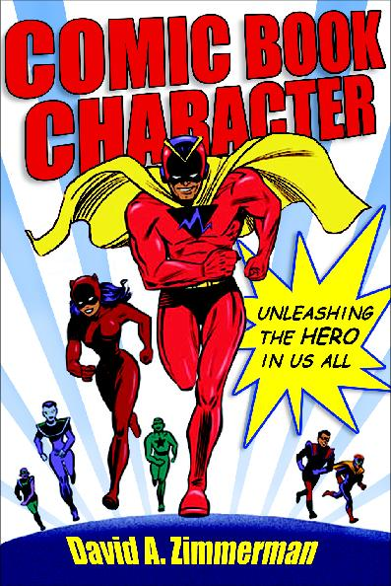

Requirements:

Due Monday May 22nd

You will be graded on two criteria …

Criterion B – ‘Communication’:
- 1 page
- Colored
- Neat
- No pencil
- Clear
- Spelling-grammar counts

Criterion E – ‘Processing Data’:
- At least 4 (four) references to properties of matter (General and Specific properties)
- Bonus if you can relate it to something we have studied previously in class …
- Try to be original, creative, stylish, and fun!

