Science – Grade 7 Name:
Mr. Carl Love Date:
OneWorld Project
Desktop Publishing and the Environment

To start - you must research a country and find some environment issues associated with it.
May of this year is our school’s environmental focus month and it is an Area of Interaction. I want you to prepare a 2 page newsletter on Publisher highlighting some environmental issues associated with a particular country. Highlight what the country does, does not do, solutions, impact (even around the world), etc. You should probably be able to find at least 3 sources of different information for your country to make this a good project.

Newsletter
Guidelines:

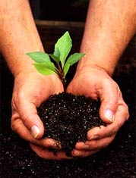
- 2 pages long
- use lots of visual aids
- have a table of contents
- make sure it is not too crowded or too empty
- use font size 10-12 for regular text
- be comfortable with the words you write – make sure they are your own
- use at least 3 sources, print them out first before Mr. Love can reserve your country
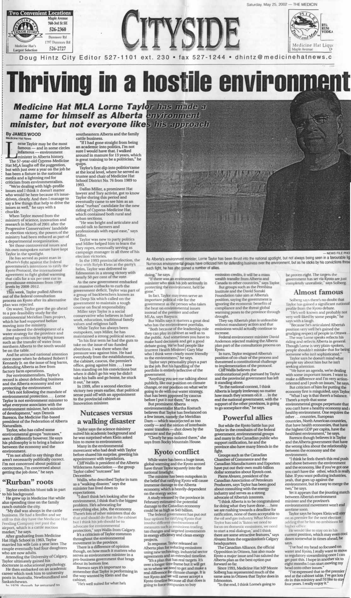
- if you can relate it to something we have studied in class – AWESOME!
- Spelling and grammar does count!

Assessment

You will be assessed using MYP criterions ‘One World’ and ‘Communication’

Level | One World  Criterion A | Communication  Criterion B
1-2 | I explained a little bit about why this condition is important and how it affects the country and our world. | My newsletter is simply and easy to understand. I use some correct science vocabulary some of the time.
3-4 | I explain most all of the main points about how the condition affects the country. I explain how this is different from other parts of the world. | My newsletter covers all of the basics well, I use simple pictures, charts and diagrams to explain.
5-6 | I explain with detail, how the environment affects the overall state of the country (good and bad), it’s past, it’s future, how to make it better (solutions) and perhaps relate it to other parts of the world. | My newsletter clearly explains my environmental topics VERY well, even the more complex parts. I use a variety of challenging vocabulary and good visuals including charts, graphs, pictures and diagrams. All of my information is very accurate and detailed.

